NAME : DISHITA BANSAL
SUBGROUP:2C24
ROLL NO:1024030365
ASSIGNMENT -5
QUES 1: 1. Develop a menu driven program for the following operations on a Singly Linked List. (a) Insertion at the beginning. (b) Insertion at the end. (c) Insertion in between (before or after a node having a specific value, say 'Insert a new Node 35 before/after the Node 30'). (d) Deletion from the beginning. (e) Deletion from the end. (f) Deletion of a specific node, say 'Delete Node 60'). (g) Search for a node and display its position from head. (h) Display all the node values.
SOLUTION: #include<iostream>
using namespace std;
class node{
public:
int data;
node* next;
node(int value){
data = value;
next = nullptr;
}
};
class linkedlist{
private:
node* head;
public:
linkedlist(){
head = nullptr;
}
void insertatbegining(int value){
node* newnode = new node(value);
newnode->next = head;
head = newnode;
}
void insertatend(int value){
node* newnode = new node(value);
if(head == nullptr){
head = newnode;
return;
}
node* temp = head;
while(temp->next!=nullptr){
temp = temp->next;
}
temp->next = newnode;
}
void insertafter(int prevalue,int value){
node* temp = head;
while (temp != nullptr && temp->data != prevalue) {
temp = temp->next;
}
if (temp == nullptr) {
cout << "Previous node not found!\n";
return;
}
node* newNode = new node(value);
newNode->next = temp->next;
temp->next = newNode;
}
void deleteatbeginning(){
if (head == nullptr){
return;
}
node* temp = head;
head = head->next;
delete temp;
}
void deleteatend(){
if(head == nullptr){
return;
}
if(head->next == nullptr){
delete head;
head = nullptr;
return;
}
node* temp = head;
while(temp->next->next!= nullptr){
temp = temp->next;
}
delete temp->next;
temp->next = nullptr;
}
void deletebyvalue(int value){
if(head == nullptr){
return;
}
if(head->data == value){
node* temp = head;
head = head->next;
delete temp;
return;
}
node* temp = head;
node* prevnode = nullptr;
while(temp!=nullptr && temp->data!= value){
prevnode = temp;
temp = temp->next;
}
if(temp == nullptr){
return;
}
prevnode->next = temp->next;
delete temp;

}
int search(int key) {
node* temp = head;
int pos = 1;

while (temp != nullptr) {
if (temp->data == key) {
return pos;
cout<<"value found at "<<pos;
}
temp = temp->next;
pos++;
}
return -1;
}
void printlist(){
node* temp = head;
while(temp!=nullptr){
cout<<temp->data<<" -> ";
temp = temp->next;
}
}

};
int main(){
linkedlist l;
int choice;
do{
cout<<"\n==MENU DRIVEN==\n";
cout<<"Option 1: Insertion at the beginning\n";
cout<<"Option 2: Insertion at the end\n";
cout<<"Option 3: Insertion in between\n";
cout<<"Option 4: Deletion from the beginning.\n";
cout<<"Option 5: Deletion from the end.\n";
cout<<"Option 6: Deletion of a specific node\n";
cout<<"Option 7: Search in linked list .\n";
cout<<"Option 8: Display all the node values.\n";
cout<<"Option 9: Exit\n";
cout<<"Enter your choice:";
cin>>choice;
switch(choice){
case 1 :
int value;
cout<<"Value: ";
cin>>value;
l.insertatbegining(value);
break;
case 2 :
int value1;
cout<<"Value: ";
cin>>value1;
l.insertatend(value1);
break;
case 3 :
int value5,value2;
cout<<"Value: ";
cin>>value5;
cout<<" prev node value: ";
cin>>value2;
l.insertafter(value2,value5);
break;
case 4 :
l.deleteatbeginning();
break;
case 5:
l.deleteatend();
break;
case 6:
int value4;
cout<<"Value to be deleted";
cin>>value4;
l.deletebyvalue(value4);
break;
case 7:
int value3;
cout<<"Value to be searched :";
cin>>value3;
l.search(value3);
break;
case 8 :
l.printlist();
break;
case 9:
cout<<"Exit";
}
}while(choice!=9);

}

Output:

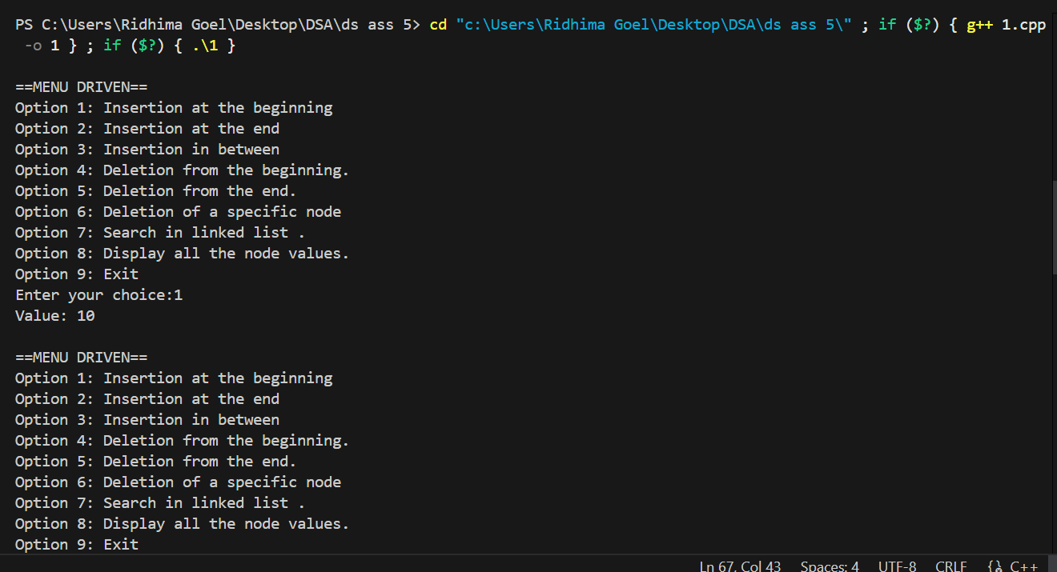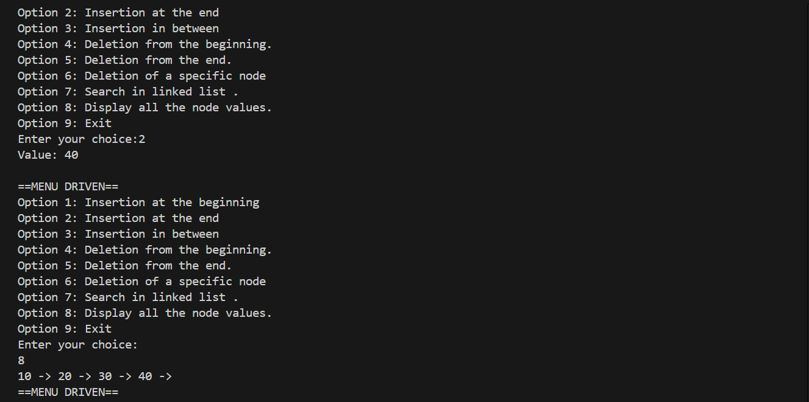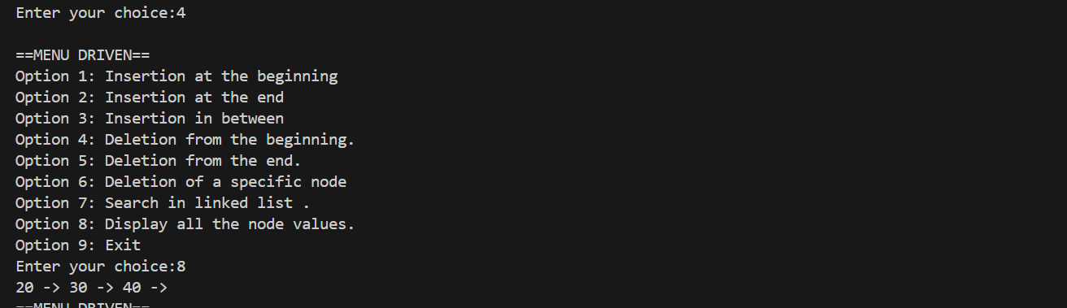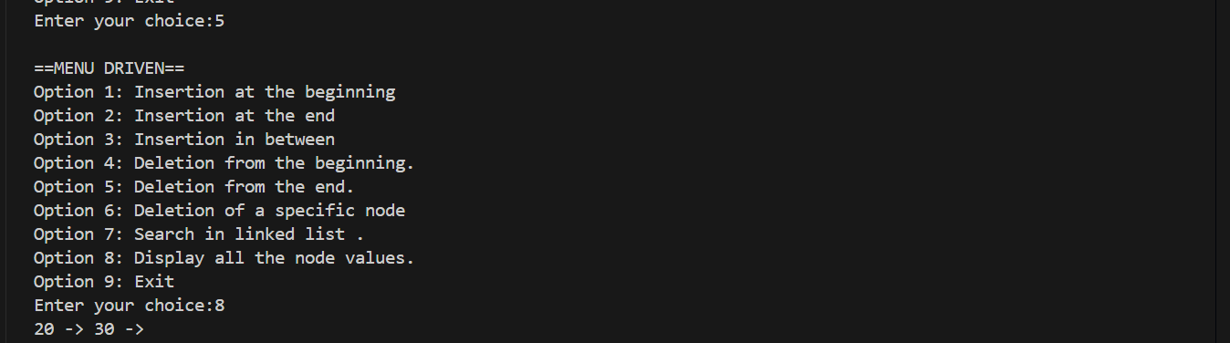
Ques 2:Write a program to count the number of occurrences of a given key in a singly linked list and then delete all the occurrences. Input: Linked List : 1->2->1->2->1->3->1 , key: 1 Output: Count: 4 , Updated Linked List: 2->2->3.
Solution:
#include <iostream>
using namespace std;

struct Node {
int data;
Node* next;
Node(int val) {
data = val;
next = NULL;
}
};

// Function to insert node at end
void insert(Node*& head, int val) {
Node* newNode = new Node(val);
if (head == NULL) {
head = newNode;
return;
}
Node* temp = head;
while (temp->next != NULL) {
temp = temp->next;
}
temp->next = newNode;
}

// Function to display linked list
void display(Node* head) {
Node* temp = head;
while (temp != NULL) {
cout << temp->data;
if (temp->next != NULL) cout << "->";
temp = temp->next;
}
cout << endl;
}

// Function to count occurrences and delete them
int countAndDelete(Node*& head, int key) {
int count = 0;

// Handle head nodes having the key
while (head != NULL && head->data == key) {
Node* toDelete = head;
head = head->next;
delete toDelete;
count++;
}

Node* current = head;
Node* prev = NULL;

while (current != NULL) {
if (current->data == key) {
count++;
prev->next = current->next;
delete current;
current = prev->next;
} else {
prev = current;
current = current->next;
}
}

return count;
}

// Driver Code
int main() {
Node* head = NULL;

// Creating linked list: 1->2->1->2->1->3->1
insert(head, 1);
insert(head, 2);
insert(head, 1);
insert(head, 2);
insert(head, 1);
insert(head, 3);
insert(head, 1);

cout << "Original Linked List: ";
display(head);

int key = 1;
int count = countAndDelete(head, key);

cout << "Count of " << key << ": " << count << endl;
cout << "Updated Linked List: ";
display(head);

return 0;
}

Output:
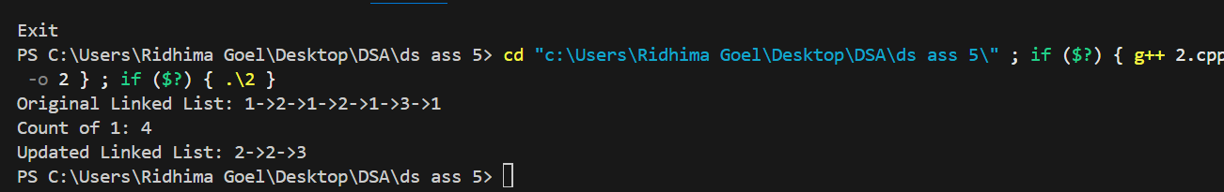

Ques 3 : 3. Write a program to find the middle of a linked list. Input: 1->2->3->4->5 Output: 3
Solution:
#include <iostream>
using namespace std;

struct Node {
int data;
Node* next;
Node(int val) : data(val), next(NULL) {}
};

// Insert at end
void insert(Node*& head, int val) {
Node* newNode = new Node(val);
if (!head) {
head = newNode;
return;
}
Node* temp = head;
while (temp->next) temp = temp->next;
temp->next = newNode;
}

// Find middle node
int findMiddle(Node* head) {
Node* slow = head;
Node* fast = head;

while (fast && fast->next) {
slow = slow->next; // move 1 step
fast = fast->next->next; // move 2 steps
}
return slow->data;
}

// Driver code
int main() {
Node* head = NULL;

// Linked List: 1->2->3->4->5
insert(head, 1);
insert(head, 2);
insert(head, 3);
insert(head, 4);
insert(head, 5);

cout << "Middle element: " << findMiddle(head) << endl;
return 0;
}
s
solution:

